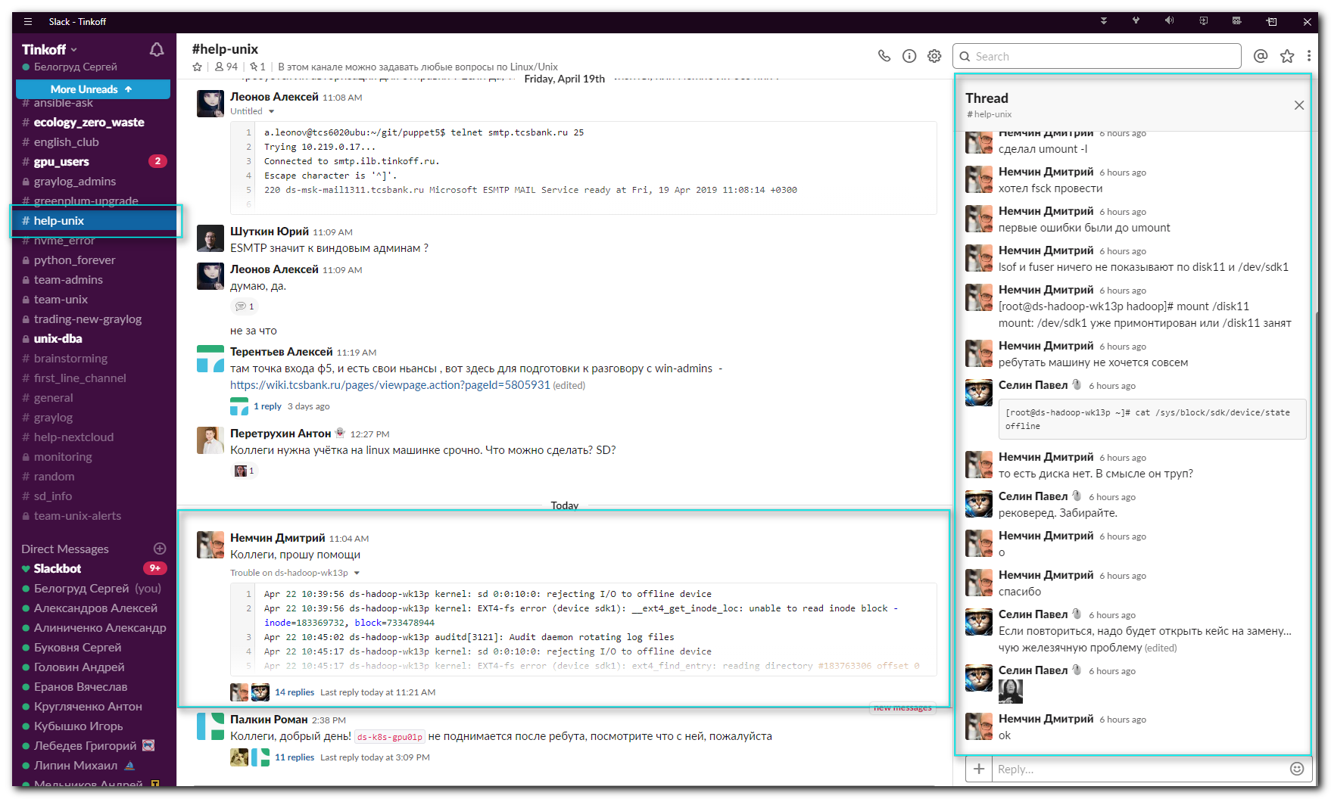

411 2019-04-22 11:08:04 cat /sys/class/block/sdk/
412 2019-04-22 11:08:11 cat /sys/class/block/sdi/ro
413 2019-04-22 11:08:27 less /var/log/messages
414 2019-04-22 11:09:36 ls -ld /sys/class/block/sdk
415 2019-04-22 11:10:20 ls -l /sys/block/sdk/device/state
416 2019-04-22 11:10:23 cat /sys/block/sdk/device/state
417 2019-04-22 11:12:23 echo online > /sys/block/sdk/device/state
418 2019-04-22 11:15:11 less /var/log/messages
419 2019-04-22 11:15:23 less /var/log/messages-20190421
420 2019-04-22 11:17:14 echo 1 > /sys/block/sdk/device/delete
421 2019-04-22 11:17:17 lsblk
422 2019-04-22 11:17:44 echo "- - -" > /sys/class/scsi_host/host0/scan
423 2019-04-22 11:17:46 lsblk
424 2019-04-22 11:18:05 less /var/log/messages
425 2019-04-22 11:18:33 fdisk -l /dev/sdn
426 2019-04-22 11:18:44 fsck /dev/sdn1
427 2019-04-22 11:19:18 cat /etc/fstab
428 2019-04-22 11:19:37 ls -l /dev/disk/by-uuid/ | grep sdn
429 2019-04-22 11:19:52 mount /disk11

